**DIRECCIÓN ACADÉMICA**

**DEPARTAMENTO DE INGLÉS**

**Respeto – Responsabilidad – Resiliencia – Tolerancia**

**Worksheet N°9  
TOPIC: Chores and other activities**

**Name: _________________________________________Grade: 4°___ Date: ____/____/2020**

**Objective:**

* To recognize different types of activities.
* For questions you can send a mail to [inglescestarosa@gmail.com](mailto:inglescestarosa@gmail.com)

1. **Look and complete the activities and organize then into the blue box.**



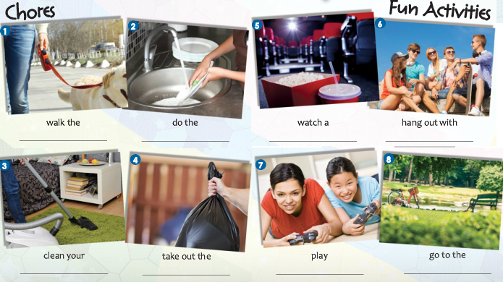

|  |  |
| --- | --- |
| Chores *(daily tasks)* | Fun activities *(Free time)* |
| 1.  2.  3.  4. | **1.**  **2.**  **3.**  **4.** |

1. **Mark with a ____when you do these activities**

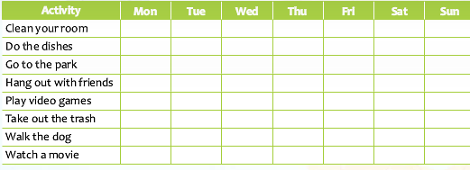

**No olvides enviar tu guía terminada con nombre y curso al correo:**

[**inglescestarosa@gmail.com**](mailto:inglescestarosa@gmail.com)

**Ej: Francisca Sanhueza 4°E**

