DIRECCIÓN ACADÉMICA
DEPARTAMENTO DE INGLÉS
Respeto – Responsabilidad – Resiliencia – Tolerancia
Worksheet N°9
TOPIC: Opinions and Adjectives

Name: _________________________________________Grade: 3°___ Date: ____/____/2020
Objective:
- To comprehend what is an adjective to give opinions and suggestions
- For questions you can send a mail to inglescestarosa@gmail.com

- Read and analyze the phone screens to resolve Item number 2 and 3.
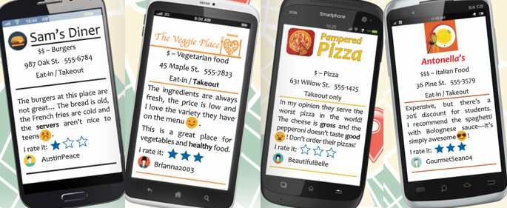

- Complete True (T) or False (F) according to the screen phones information.
- The texts are about different kind of restaurants ___
- All the Restaurants are similar ___
- The texts have different people’s opinions ___
- The Veggie Place offer funk food ___
- To eat Italian food, you can go to Antonella’s ___

- Read the text more carefully and mark with an ___ all the correct options.

