DIRECCIÓN ACADÉMICA
DEPARTAMENTO DE INGLÉS
Respeto – Responsabilidad – Resiliencia – Tolerancia
Worksheet N°10
TOPIC: Opinions and Adjectives

Name: _________________________________________Grade: 3°___ Date: ____/____/2020
Objective:
To analyze a menu and give personal opinions.
For questions you can send a mail to inglescestarosa@gmail.com
- Read the following conversation and write the adjectives into the box.

Dialogue  Tom: What do you think about this Restaurant? In my opinion, it looks good.  Kathy: It´s perfect, it’s healthier than Burger King.  Tom: Kathy, what would you like to eat?  Kathy: What's that? It smells weird.  Tom: It’s Spanish omelet  Kathy: What’s Spanish omelet?  Tom: It’s made with egg and potatoes  Kathy: OH! That sounds disgusting.  Tom: Would you prefer?  Kathy: I prefer a slice of pizza; it is more delicious and tastier; pizza is my guilty pleasure.  Tom: Ok, but I don’t like pizza… I think it is fatty,  I would like some spaghetti and meatballs.  Kathy: Ok, and Would you like some salad too?  Tom: Thank you! I love tomatoes and lettuce because it is juicy and fresh.  Kathy: Awesome! I love this salad too. | Adjectives  1. Good  2. ______________  3. ______________  4. ______________  5. ______________  6. ______________  7. ______________  8. ______________  9. ______________  10. ____________

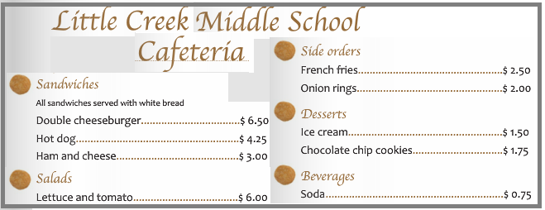
- Read the Menu about the Cafeteria and write a text in 5 lines to give your personal opinion. Choose 5 adjectives of the green box.

In my opinion,_______________  ________________________________________________________________________________________________________________________________________________________________________________________________________________________ | 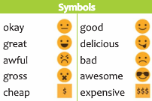

No olvides enviar tu guía terminada al correo inglescestarosa@gmail.com con nombre, apellido y curso. Además, recuerda que en nuestro Instagram y también en Classroom puedes encontrar todo el material para realizar tus guías y evaluaciones.
@english_cestarosa

