DIRECCIÓN ACADÉMICA
DEPARTAMENTO DE INGLÉS
Respeto – Responsabilidad – Resiliencia – Tolerancia
Evaluation N°4
TOPIC: Predictions and Plans

Name: _________________________________________Grade: 4°___ Date: ____/____/2020
Objective:
- To remember grammar rules about future and would.
- For questions send a mail to inglescestarosa@gmail.com
- Fecha máxima de entrega viernes 25 de septiembre 2020

Ideal Score: 30pts
Total Score: _____
- Match the correct answer according to the use of “would”. (12pts)

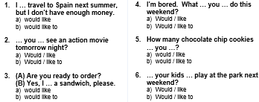

- Remember the grammar rules about would like and would like to and correct the mistake in each sentence (6pts)

o. Would you like go to the supermarket with me?
Would you like to go to the supermarket with me?

- What you like to do the next week?

- Would my sister to cook a birthday cake to our dad?

- I would like to a piece of bread, please.

- Complete the agenda with your own information using will and going to. (12pts)

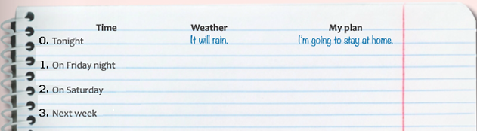

No olvides enviar tu evaluación terminada con nombre y curso al correo:

inglescestarosa@gmail.com
Ej.: Paulina Castillo 4°B

