DIRECCIÓN ACADÉMICA
DEPARTAMENTO DE INGLÉS
Respeto – Responsabilidad – Resiliencia – Tolerancia
Evaluation N°4
TOPIC: Countable and Uncountable nouns

Name: _________________________________________Grade: 3°___ Date: ____/____/2020
Objective:
- To identify and recognize countable and uncountable nouns.
- For questions send a mail to inglescestarosa@gmail.com
- Fecha máxima de entrega viernes 25 de septiembre 2020

Ideal Score: 30pts
Total Score: _____

- Write a “C” if it’s a Countable noun or “U” if it’s an uncountable noun. (12pts)

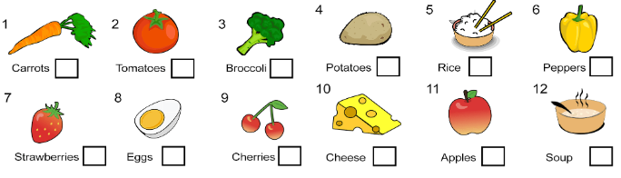

- Match the correct answer (6pts)

- We need ____tomatoes.  - A  - AN  - Some  - Any | - They don’t have ____ onions.  - A  - AN  - Some  - Any | - Are there ___ carrots?  - A  - AN  - Some  - Any
- We don’t have ___ milk.  - A  - AN  - Some  - Any | - There is ___ spaghetti.  - A  - AN  - Some  - Any | - There is ___ apple here.  - A  - AN  - Some  - Any

- Read the recipes and complete the blanks with the words in the boxes. (12pts)

FRUIT SALAD  To make a fruit salad, I need two (1) __________________  A green (2) _______________  An (3) ___________________  And some (4) _____________ | BOLOGNESE SAUCE  For Bolognese Sauce, I need a tablespoon of butter, an (5) ___________________  Six ripe 6) ________________  Some (7) _________________  Two cups of (8) ___________  And two carrots. | APPLE PIE  To make a Special Apple Pie, I need five big (9) __________  A cup of (10) __________juice  An (11) __________________  One teaspoon of (12) _______  And some flour.

