**DIRECCIÓN ACADÉMICA**

**DEPARTAMENTO DE INGLÉS**

**Respeto – Responsabilidad – Resiliencia – Tolerancia**

**Evaluation N°4  
TEMA: THE CITY**

**Name: _________________________________________Grade: 1°___ Date: ____/____/2020**

**Objective:**

* To recognize CITY PLACES AND OCCUPATIONS
* For questions send a mail to [inglescestarosa@gmail.com](mailto:inglescestarosa@gmail.com)
* ***FECHA MAXIMA DE ENTREGA: VIERNES 25 DE SEPTIEMBRE DEL 2020***

Ideal score: 30 pts

Total score: ___ pts

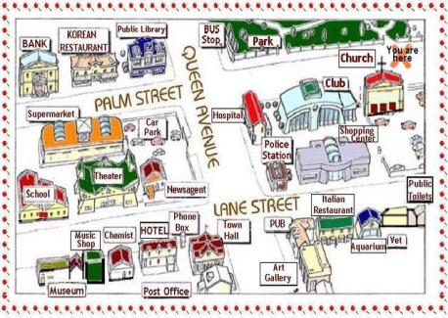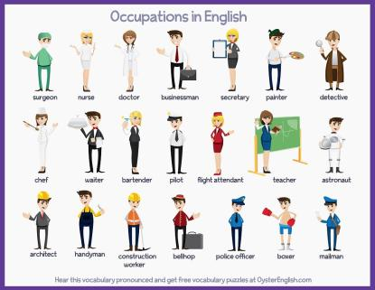

1. Write T (true) or F (false) depending on the sentence. (6 PTS)

|  |  |  |
| --- | --- | --- |
| 1. |  | The clown works in an office |
| 2. |  | The teacher works in the school |
| 3. |  | You live in a house or apartment |
| 4. |  | The artist works in a bank |
| 5. |  | The nurse works in a hospital |
| 6. |  | The park is full of trees |

1. Match the worker and the place they work A to B (8 PTS)

|  |  |
| --- | --- |
| A | B |
| 1. POLICE OFFICER | ____ FIRE STATION |
| 1. FIRE FIGHTER | ____ BAKERY |
| 1. WAITER | ____ AIRPORT |
| 1. POSTMAN | ____ POLICE STATION |
| 1. PILOT | ____ RESTAURANT |
| 1. LAWYER | ____ COURT |
| 1. DOCTOR | ____ POST OFFICE |
| 1. BAKER | ____ HOSPITAL |

1. Multiple choice. Select the correct alternative. (6 PTS)

|  |  |
| --- | --- |
| 1. Person who works in TV: 2. Journalist 3. Baker 4. Scientist 5. Mechanic | 1. Person who takes pictures: 2. Mechanic 3. Photographer 4. Baker 5. Gardener |
| 1. Person who fixes cars: 2. Baker 3. Journalist 4. Mechanic 5. Dancer | 1. Place where you watch a football game: 2. Butchery 3. Museum 4. Supermarket 5. Stadium |
| 1. Place where you can swim: 2. Stadium 3. Bakery 4. Supermarket 5. Swimming pool | 1. Place where you can watch a movie: 2. Supermarket 3. Museum 4. Cinema 5. Bridge |

IV. Answer the following questions (10 PTS)

1. Where do you see a statue?

___________________________________________________________________

2. Where do you visit animals?

___________________________________________________________________

3. Who cooks in a restaurant?

___________________________________________________________________

4. Who works in a court apart from a lawyer?

___________________________________________________________________

5. What would you like to be when you grow up?

___________________________________________________________________



Practicando lo aprendido durante las 2 guías trabajadas anteriormente realiza las actividades propuestas. I contesta T o F dependiendo si la oración es verdadera o falsa. II pasa los conceptos de la fila A a la B según sus lugares de trabajo. III selecciona la alternativa correcta según la oración presentada y IV responde las preguntas con la información aprendida y tu información.

RECUERDA ENVIAR TU TRABAJO AL CORREO [inglescestarosa@gmail.com](mailto:inglescestarosa@gmail.com) hasta el dia ***25 de septiembre.***

Indicando tu nombre, apellido y curso.

Por ejemplo: Paola Garrido 1E