DIRECCIÓN ACADÉMICA
DEPARTAMENTO DE INGLÉS
Respeto – Responsabilidad – Resiliencia – Tolerancia
Worksheet N°8
TOPIC: Future Will and Going to

Name: _________________________________________Grade: 4°___ Date: ____/____/2020
Objective:
- To identify the differences between will and going.
- For questions send a mail to inglescestarosa@gmail.com

- Read the grammar box to recognize the differences between will and going to, and complete Item N°II.

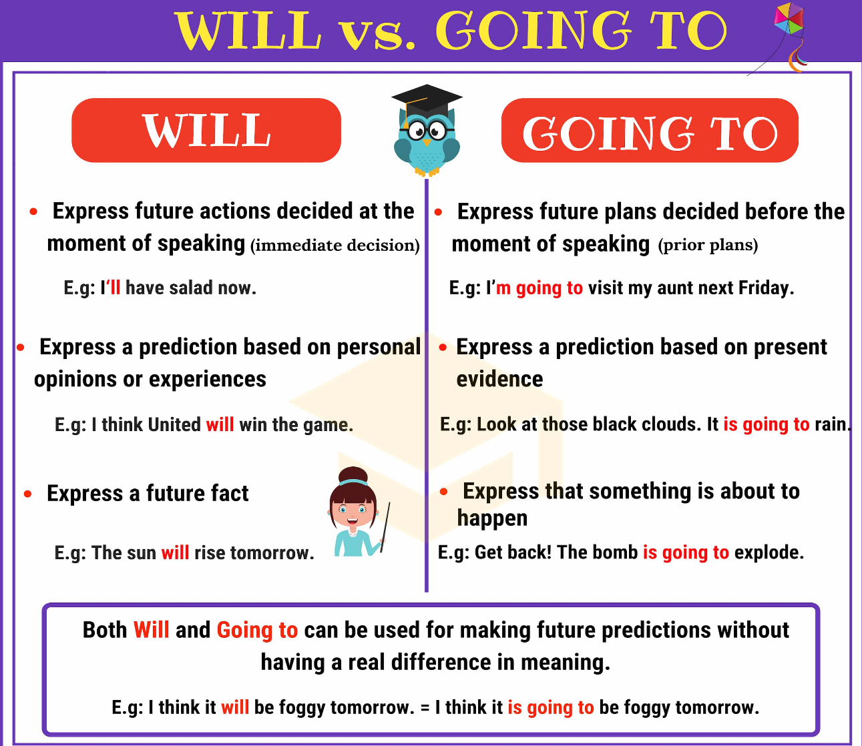

- Match the correct answer according to the rules of will and going to.

- Look at the sky! It is going to / will rain soon.
- Next summer I am going to / will backpack around Latin America.
- Ring Ring! I am going to / will open the door.
- I think our favorite team is going to / will win the match this afternoon.
- In 2070 robots are going to /will be our teachers.
- Tonight, we are going to / will have a birthday party for my bother.
- I am going to / will carry your books.
- During winter vacation we are going to / will watch Netflix every day.
- I’m sure that you are going to / will find your new ring.
- I doubt that he is going to / will pass the English test.

