DIRECCIÓN ACADÉMICA
DEPARTAMENTO DE INGLÉS
Respeto – Responsabilidad – Resiliencia – Tolerancia
Worksheet N°7
TOPIC: Would like and Would like to

Name: _________________________________________Grade: 4°___ Date: ____/____/2020
Objective:
- To identify and comprehend the use the modal verb would.
- For questions send a mail to inglescestarosa@gmail.com

- Read and study the box about the grammar rules of would like and would like to.

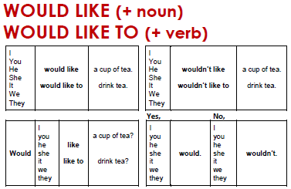
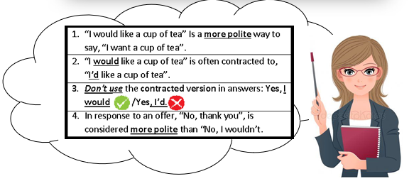

- Study the above boxes and complete the sentences using would like or would like to.

