DIRECCIÓN ACADÉMICA
DEPARTAMENTO DE INGLÉS
Respeto – Responsabilidad – Resiliencia – Tolerancia
Ideal Score: 30pts
Total Score: _____
ENGLISH TEST N°3
TOPIC: Future Will and Going to

Name: _________________________________________Grade: 4°___ Date: ____/____/2020
Objective:
- To remember grammar rules about future will and going to.
- For questions send a mail to inglescestarosa@gmail.com

- Read the information about Aiden’s schedule and match the correct answer. (12 pts)
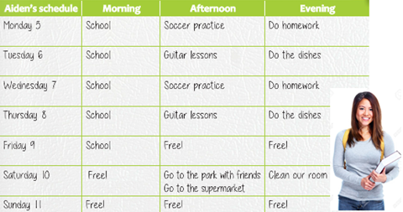

- What is Aiden going to do Tuesday and Thursday afternoon?  - She is going to do the dishes  - She is going to play soccer  - She is going to play guitar | - Is Aiden going to the supermarket on Saturday afternoon?  - Yes, she is, and also, she is going to meet some friends.  - Yes, she is, and also, she is going to the park.  - All of the above.
- Is Aiden going to have free time on Friday and Sunday afternoon?  - Yes, she is.  - No, she isn´t.  - None of the above. | - When are Aiden and her sister going to clean their room?  - They are going to clean on Saturday evening  - They are going to clean on Sunday morning.  - They aren’t going to clean their room.

- Look at this weekly planner and write 3 sentences using going to. (6pts)

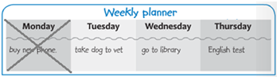

- __________________________________________.
- __________________________________________
- __________________________________________
- __________________________________________

- Use the words to make predictions (will or won’t) (12pts)

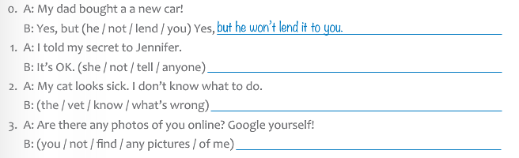

No olvides enviar tu Evaluación terminada con nombre, apellido y curso al correo: inglescestarosa@gmail.com
Ej: Camila Zambrano 4°A

