DIRECCIÓN ACADÉMICA
DEPARTAMENTO DE INGLÉS
Respeto – Responsabilidad – Resiliencia – Tolerancia
Worksheet N°8
TOPIC: Countable v/s Uncountable nouns

Name: _________________________________________Grade: 3°___ Date: ____/____/2020
Objective:
- To recognize the difference between a, an, some and any.
- For questions you can send a mail to inglescestarosa@gmail.com
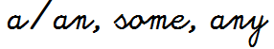

- Pay attention to the grammar box about of countables and uncountables nouns and complete Item N°2.

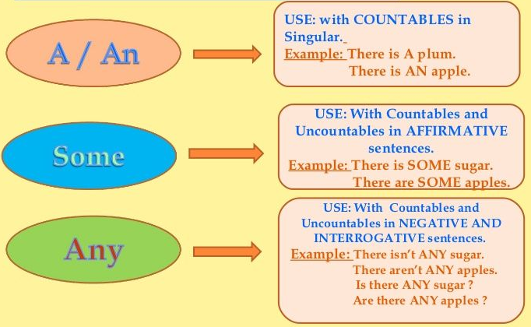

- Complete the sentences using a, an, some and any. Remember the grammar rules.

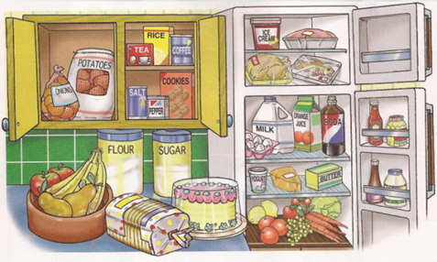

- There is _____________ apple on the fruit bowl.
- There is ______________ butter in the fridge.
- There isn’t ____________ sugar in the pantry.
- There is _____________ birthday cake on the table.
- Are there ____________ carrots in the fridge?
- Is there _____________ orange in the fridge?
- There aren´t ____________ potatoes in the pantry.
- Are there ______________ onions in the kitchen?
- There is ______________ milk in your fridge.
- There is _____________ pepper in the first drawer.

