DIRECCIÓN ACADÉMICA
DEPARTAMENTO DE INGLÉS
Respeto – Responsabilidad – Resiliencia – Tolerancia
Worksheet N°7
TEMA: Countable v/s Uncountable nouns

Name: _________________________________________Grade: 3°___ Date: ____/____/2020
Objective:
- To recognize the difference between countable and uncountable nouns.
- For questions you can send a mail to inglescestarosa@gmail.com

- Read the recipe and classify the ingredients into the yellow box.
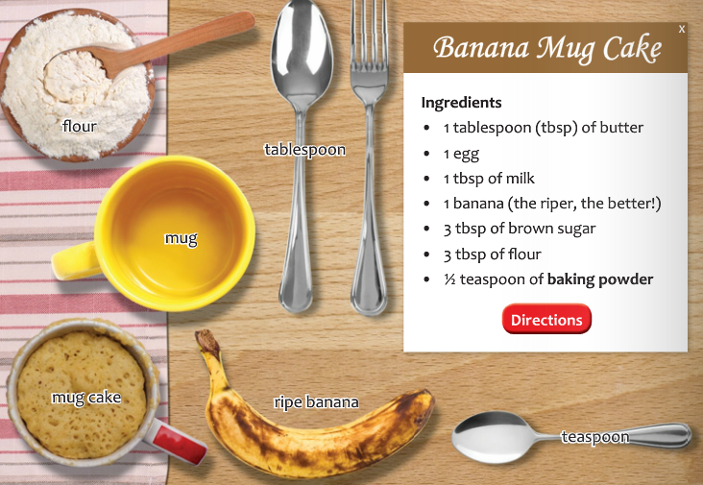

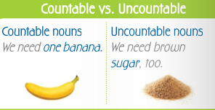
Countable nouns  Separate Ingredients we can count | Uncountable nouns  Mass Ingredients we need to measure
1. 1 Ripe banana  2. | 1.  2.  3.  4.  5.

- Mark the sentences +(affirmative) – (negative) or? (a question)

