DIRECCIÓN ACADÉMICA
DEPARTAMENTO DE INGLÉS
Respeto – Responsabilidad – Resiliencia – Tolerancia
Ideal Score: 30pts
Total Score: _____
ENGLISH TEST N°3
TOPIC: Junk and healthy food

Name: _________________________________________Grade: 3°___ Date: ____/____/2020
Objective:
- To identify and recognize vocabulary about food.
- For questions send a mail to inglescestarosa@gmail.com

- Read the text and complete the sentences. (8 pts)

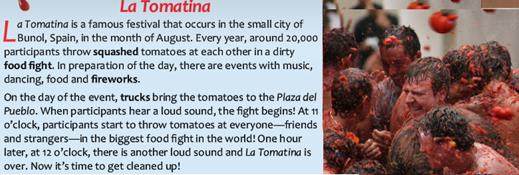

- La Tomatina Happens in Spanish city of _____________________.
- The festival is always in the month of ______________________.
- During the food fight, people throw ________________________.
- The participants start to throw tomatoes at __________________.

II. Unscramble the words about food.(10 pts)

- FEBE ______________________________
- LIKM ______________________________
- ECESEH ______________________________
- IHSF ______________________________
- TUTERB ______________________________

III. Put the numbers of Row A into Row B. Pay attention to the distractors. (12 pts)

ROW A  - This grane is very polular in China and Japan.  - You need this vegetable to make Bolognese sauce.  - The most popular fruit to make juice.  - You can eat this fried, scrambled or in a omelet.  - People say this vegetable is good for eyes.  - Salmon and tuna are popular kind of this food. | ROW B  __________ a. Orange  __________ b. Lettuce  __________ c. Carrot  __________ d. Rice  __________ e. Tomatoe  __________ f. Eggs  __________ g. Fish  __________ h. Potatoe

No olvides enviar tu Evaluación terminada con nombre, apellido y curso al correo: inglescestarosa@gmail.com
Ej: Fernando Gonzales 3°C

