DIRECCIÓN ACADÉMICA
DEPARTAMENTO DE INGLÉS
Respeto – Responsabilidad – Resiliencia – Tolerancia
GUÍA EN CASA
TEMA: How do you geta round?

Name: _________________________________________Grade: 3°___ Date: ____/____/2020

Objective:
- To recognize places and buildings in the city
- To give directions to get a place
- To identify signals in the city

- Write the correct building in each picture.

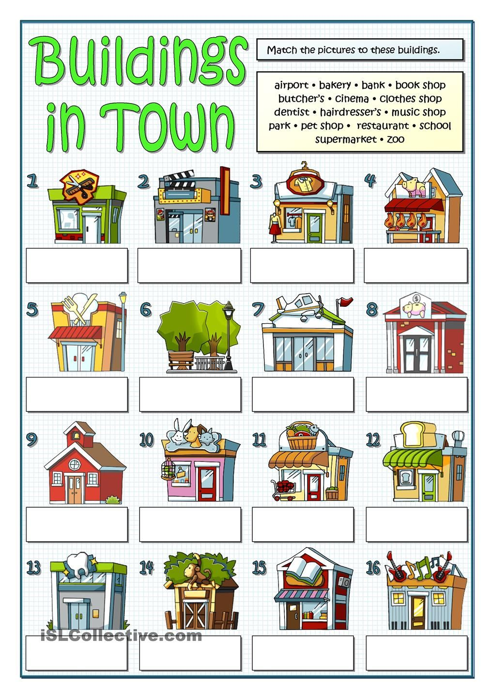

- Find these buildings in town in the word search and write them below each picture.

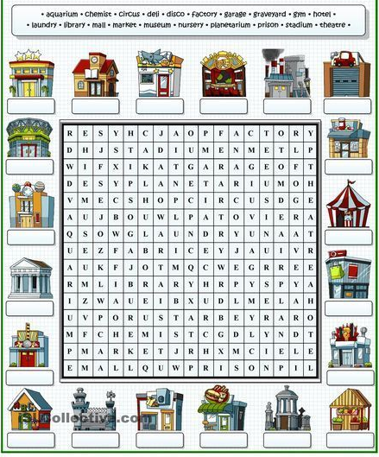

- Identify and comprehend the directions in the city.
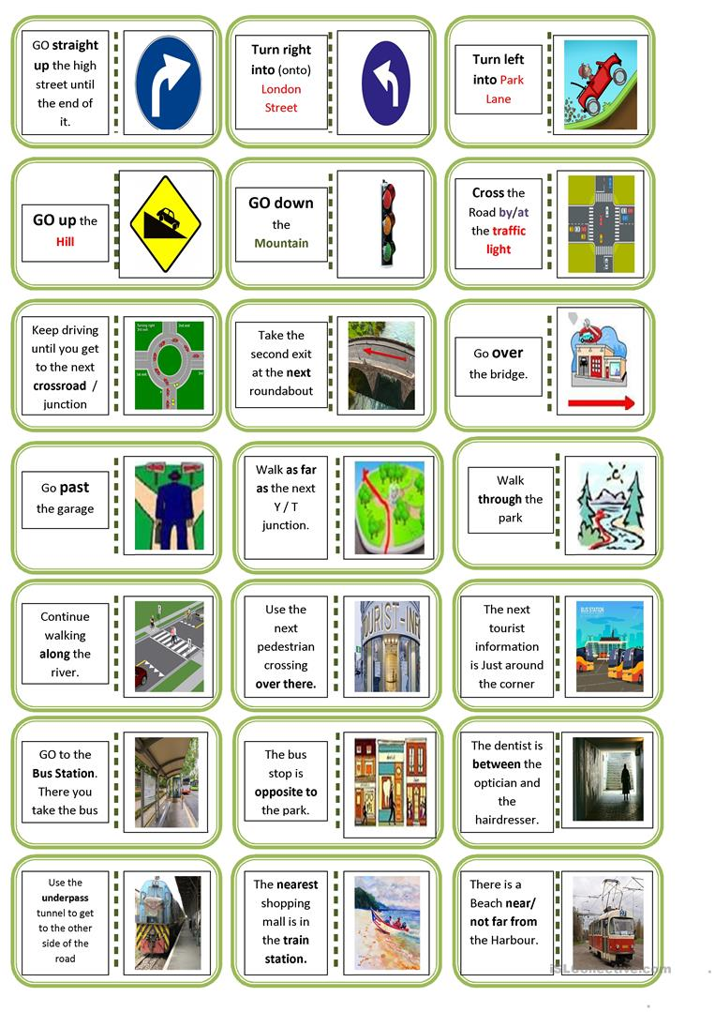

- Match the questions with the answers. (join with arrows of different colour).

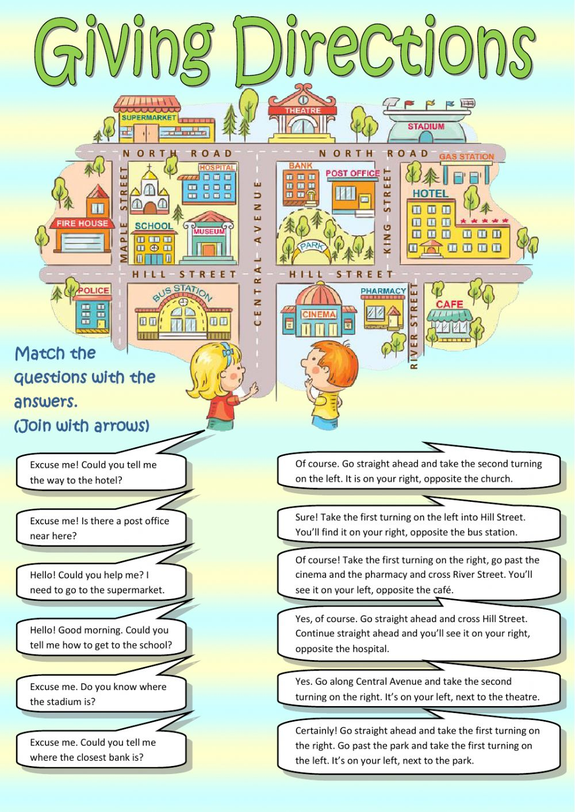

- Using the picture above, write simple instructions to go from the police station to stadium.

_______________________________________________________________________________________________________________________________________________________________________________________________________________________________________________________________________________________________________________________________________________________________________________________________________________________________________________________________________________________________________________________________________________________________________________________________________________________________________.

