DIRECCIÓN ACADÉMICA
DEPARTAMENTO DE INGLÉS
Respeto – Responsabilidad – Resiliencia – Tolerancia
GUÍA EN CASA
TEMA: What´s your routine?

Name: _________________________________________Grade: 2°___ Date: ____/____/2020

Objective:
- To recognize family members and comprehend the family structure.
- To identify house parts and house furniture.

- Recognize family members.

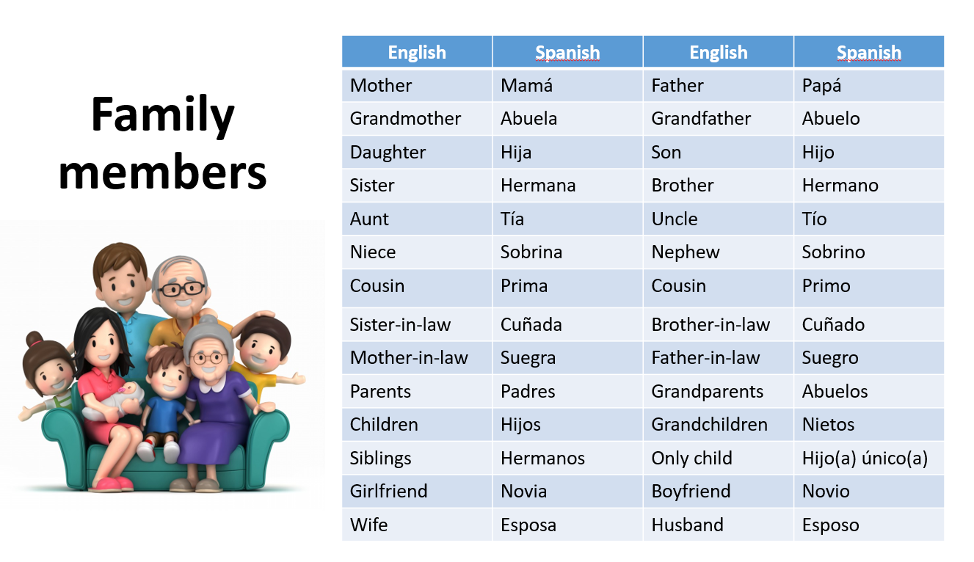

- Complete the picture with family members names.

- Identify house parts and its furniture.

Parts of the house
- attics | - laundry
- bathroom | - bedroom
- kitchen | - living room
- basement | - dining room
- garden | - yard
- hall | - stairs
- balcony | - guest room

Furniture
Armchair | Table | Chair
Curtains | Stove | Clock
Bed | Coffee table | Refrigerator
Desk | Lamp | Sofa
Mirror | Television | Carpet
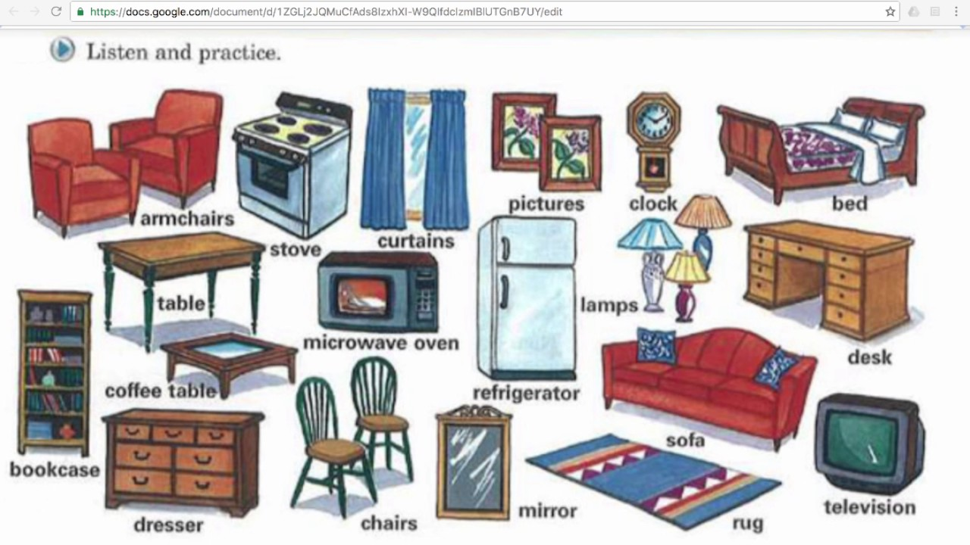

- Complete the house parts in the picture with A item. In B write the part of the house in which you can find the object presented in the sentence and finally in C answer yes or no according to the picture.
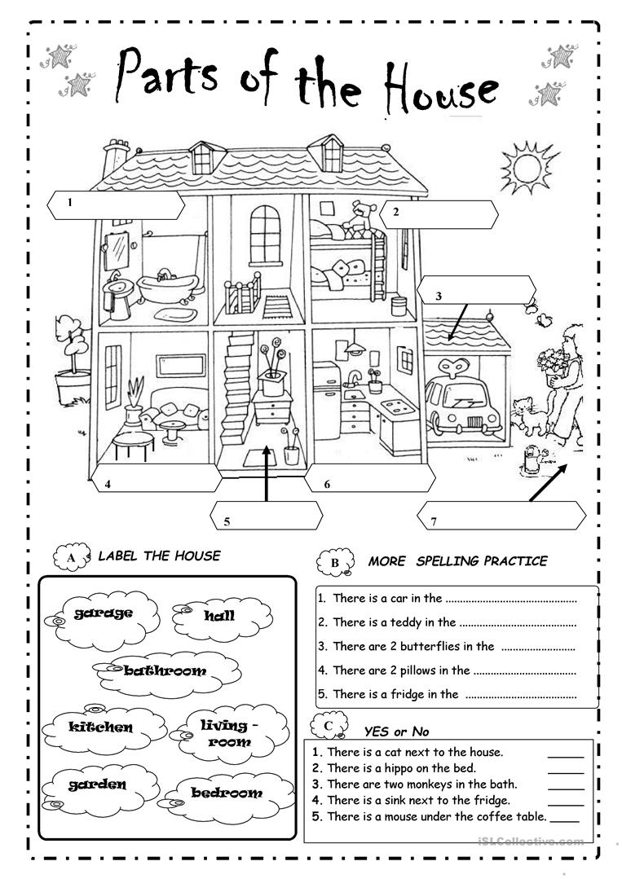

- Write sentences using there is/ there are, one of the elements presented in the list and one room of the house.

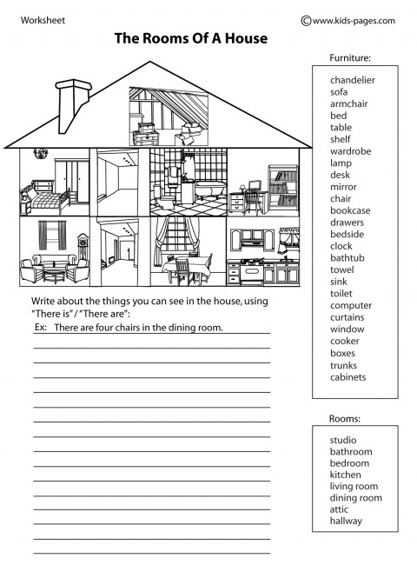

- Complete the furniture names with the missing letters.

- Where can you see those furnitures above? Classify them and write in the boxes below.

