DIRECCIÓN ACADÉMICA
DEPARTAMENTO DE INGLÉS
Respeto – Responsabilidad – Resiliencia – Tolerancia
GUÍA EN CASA
TEMA: What´s your name?

Name: _________________________________________Grade: 1°___ Date: ____/____/2020

Objective:
- To recognize family members and comprehend the family structure.

- Recognize family members.

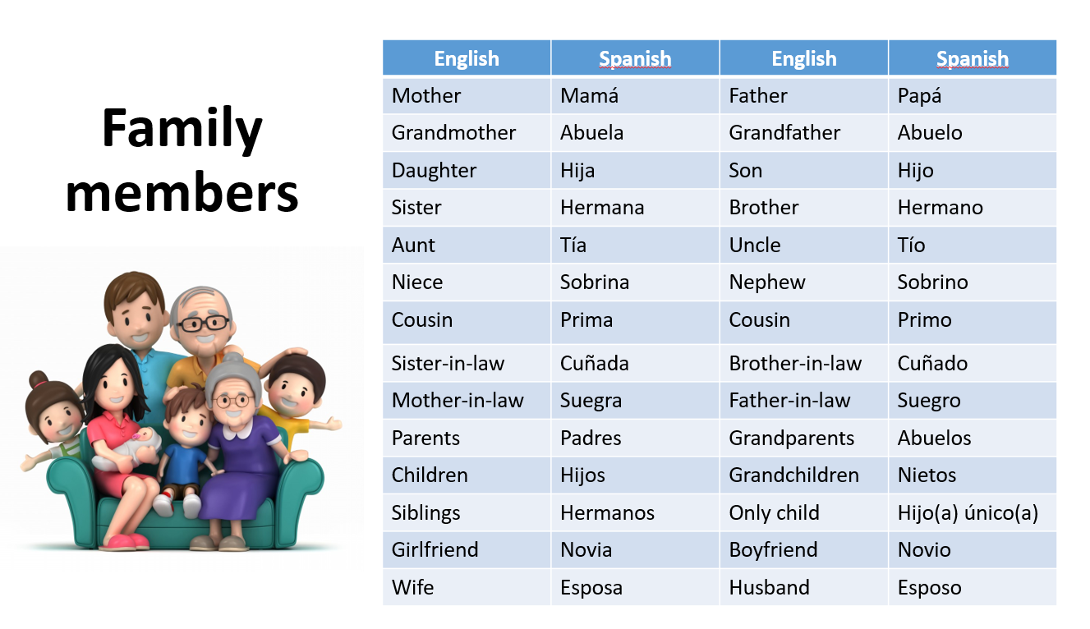

- Complete the picture with family members names.

- Use the words above and write about the Simpson family.

- According to the family tree information complete 2 exercises below.
1 exercise: answer the questions in relation to Damon.
2 exercise: answer the questions with yes or no according to the picture.

